# Assignment 2 Design Document

**Chat Client GUI Design Proposal**

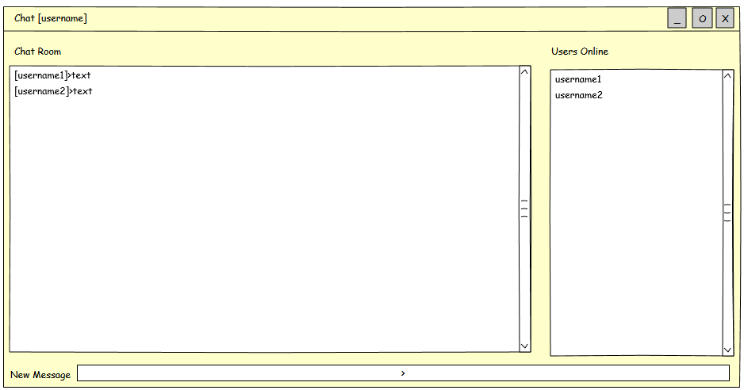

Figure 1 GUI Design

Chat GUI will have 3 main parts:

1. **Char Room text pane**: here will user see all the messages from all users appearing from up to down. Text should role up if the text pane is fully filled up. There will be some kind of color scheme introduced as well.
2. **Users Online text pane**: here will user see all the online users
3. **New message text field**: user can write a new message here and on ENTER message will be send to server and populate on every connected user Chat Room text pane